CS Dept. student job hunting tracking system-Midterm

1. Team Member

Haorui Chen (4454226030), Zihao Zhang (4798698599), Zehao Li (3717211170)

1. DB Interaction schema

Create/Update/Delete: changes are made in Firebase and My SQL simultaneously for easy sync.

Read: Available to choose the DB source to read from (though content would be the same)

1. Web app Interface

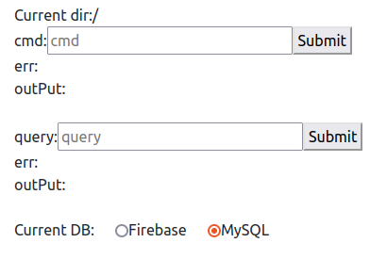

There are 3 major parts in the app respectively for command, query and source DB switch. The command form is for part 1, while the query form is for part 2.

Forms for commmand and query are basically the same: an input box for command+parameters/query, a submit button, and output for error and result, except that the command form also displays current directory that help users to traverse the file system.

The sourceDB handler at below implements the DB switch functionality, allowing us to test data correctness and consistency between DBs.

1. MySQL Database Structure

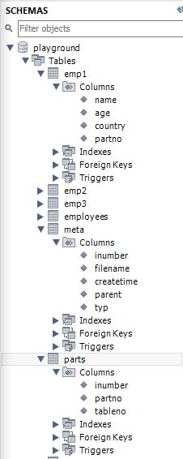

The ‘meta’ table and ‘parts’ table together emulate the name node of HDFS, where ‘meta’ table stores the directory structure of the file system (‘parent’ attribute storing the inumber of parent dir of current file/dir, ‘type’ attribute can be ‘d’-dir/’f’-file), and ‘parts’ stores the relationship of a file and different partitions (‘tableno’ attribute).

‘parts’ table is decoupled from ‘meta’ table to eliminate partial dependency.

1. Commands test with MySQL-simulated file system
   1. mkdir

Given the initial state of name node,

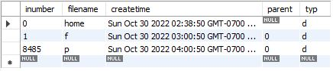

We add a new dir called ‘newdir’, then web app and DB will look like:

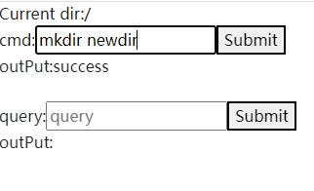

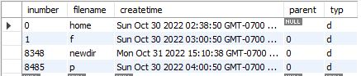

* 1. ls

Now we see the content of root dir ‘/’:

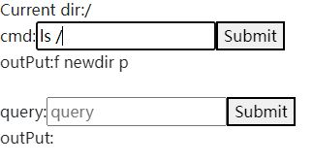

* 1. put

We upload a file ‘emp.json’ to the file system, under the ‘/newdir’, and split the content into 3 parts

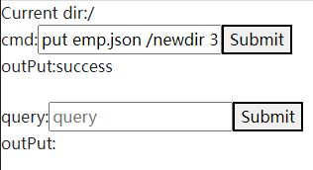

,with content of ‘emp.json’ being

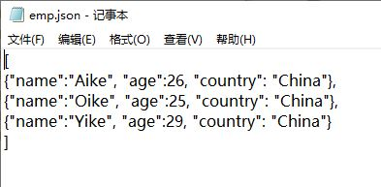

, and the DB will be like:

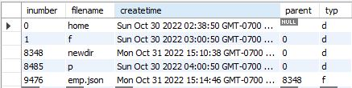

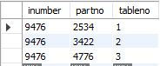

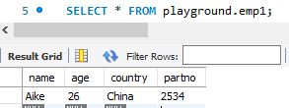

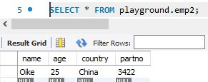

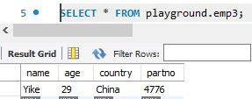

* 1. cat

if we try to see the content of ‘emp.json’ we just uploaded, we can see the whole content is displayed correctly:

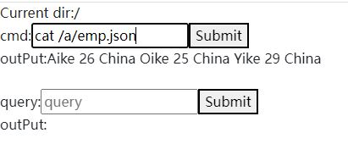

* 1. getPartitionLocatons

and we also can retrieve all location of partitions, which corresponds to the ‘partno’ attribute in 3 ‘emp1’ table respectively.

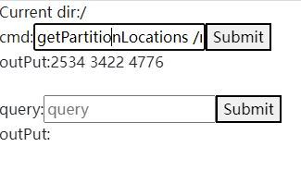

* 1. readPartition

now if we want to retrieve the 3rd partition of ‘emp.json’, we can see the corresponding content

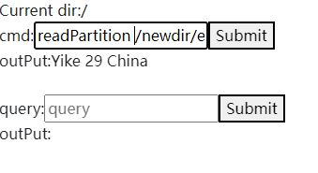

* 1. rm

lastly, if we remove the ‘newdir’ dir we added at the ‘mkdir’ step, we can see the dir is removed successfully from updated ‘meta’ and ‘parts’ table:

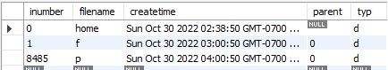



1. FireBase Database Structure

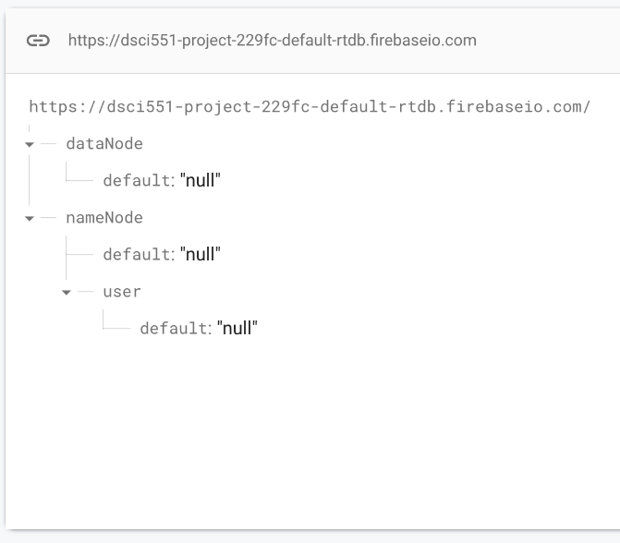

‘dataNode’ & ‘nameNode’ serves as 2 root path for actual data and file system structure respectively.

Current Firebase version is written with python, we are undergoing the process of migrating to javascript.

1. Commands test with Firebase-simulated file system
   1. mkdir

We make dir ‘john’, ‘mary’ under ‘user’ respectively.

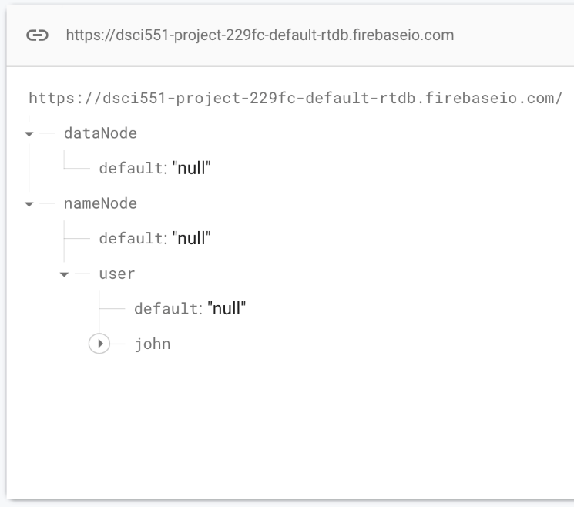

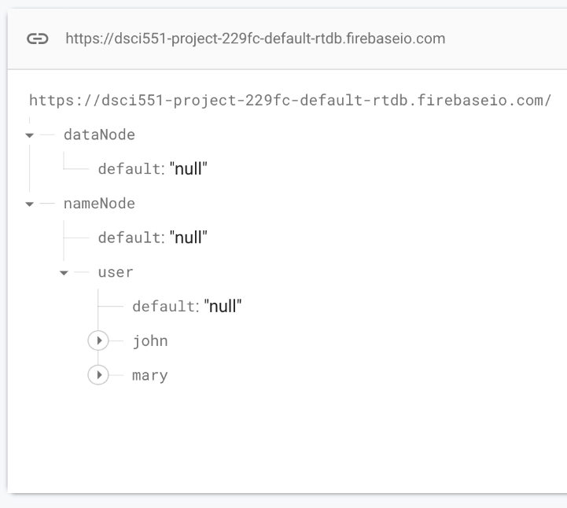

* 1. put

We upload cars.csv used in homework 1 to the Firebase, in nameNode we have

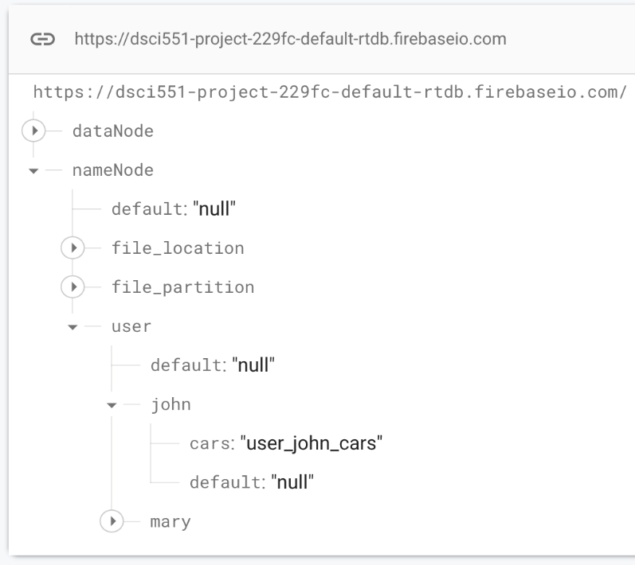

, while in dataNode we have

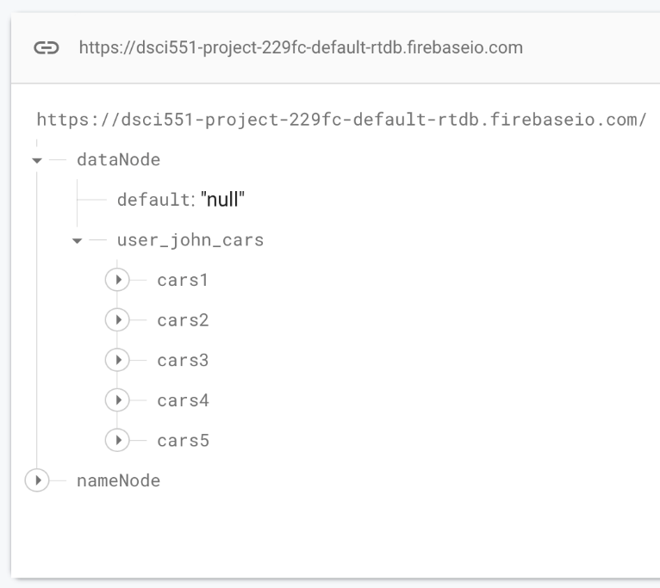

* 1. rm

now when we remove this cars.csv, in nameNode:

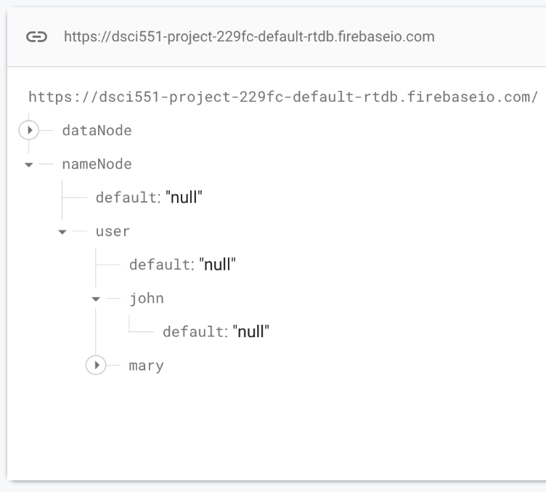

in dataNode:

